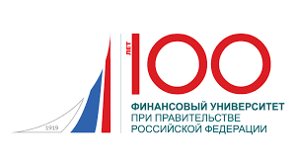 | 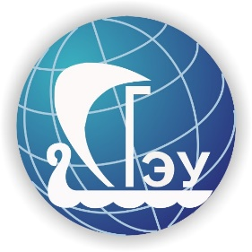

International Conference
“Engineering Innovations
and Sustainable Development”

17th-18th June 2021

organized by

Samara State University of Economics
Financial University under the Government
of the Russian Federation
Samara State Transport University

Our Partners:
Moscow State Institute of International Relations
of the Ministry of Foreign Affairs of the Russian Federation (MGIMO University) &
Polytechnic Institute of Porto, Portugal
& Institute of Technology and Business in České Budějovice, Czech Republic
ABOUT THE CONFERENCE

One of the main objectives of the conference is to share knowledge, experience, ideas and plans related to sustainable innovative development and international cooperation between educational, governmental, scientific, and business structures.
We expect that the conference participants from various world countries and regions will present their unique views and positions related to innovative and sustainable development perspectives of our society. Representatives of various professional fields will try to give their assessment of the ongoing changes to collect a single puzzle reflecting global, national, regional and local expectations and moods for the future technological development.
This conference is an attempt to consider changes, crisis and innovative processes in socio-economic (engineering and environmental) systems through the prism of technology, economics, management, law, and environmental science.

Conference topics include, but are not limited to, the following:

- Current trends in the industrial and agricultural development;
- Innovations in the construction and transport sectors;
- Problems of financing innovation processes and state support for innovations;
- Engineering education in the era of new technologies;
- Sustainable development in the context of innovations: Economic, environmental and information aspects.

PAPER SUBMISSION

All the paper should be submitted via the conference e-mail:
sseu.sp@gmail.com

SUBMISSION GUIDELINES
- Paper Submission is open from April 1, 2021 to May 15, 2021;
- Paper should not exceed 10 (ten) page limit;
- All papers are reviewed in English only;
- All papers must be original and not simultaneously submitted to another journal or conference (originality rate – 95%);
- Submitting a paper, the authors also send the registration form to the conference organizing committee, choosing the conference topic which the paper corresponds to;
- Authors will be informed via email of acceptance or rejection of the paper before June 1, 2021.
- If revisions are required, authors will be notified accordingly. The final camera ready paper should be submitted by June 15, 2021.

IMPORTANT DATES:

Paper Submission Deadline: May 15, 2021

Deadline for Registration: May 15, 2021

Date of Notification of Accepted Papers: June 1, 2021

Deadline for Submission of Revised Papers: June 15, 2021

CONFERENCE PROGRAMM
will be available on the Conference website on June 1, 2021.

VENUE
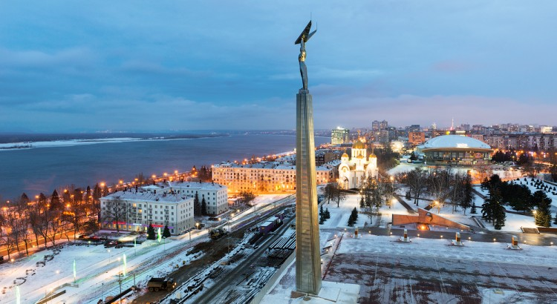
Samara, Soviet Army street, 141, 443090, SSEU

