MINISTRY OF EDUCATION AND SCIENCE
OF THE RUSSIAN FEDERATION
SAMARA STATE ECONOMIC UNIVERSITY
UNIVERSITY (SSUE)
FINANCIAL UNIVERSITY UNDER THE GOVERNMENT OF THE RUSSIAN FEDERATION
RUSSIAN STATE SOCIAL UNIVERSITY
KAZAN INNOVATIVE UNIVERSITY NAMED AFTER V.G. TIMIRYASOV (IEPU)
RESEARCH INSTITUTE OF INDUSTRY MANAGEMENT
LENKORAN STATE UNIVERSITY
(LENKORAN, AZERBAIJAN)
JUSTUS LIEBIG UNIVERSITY (GIESSEN, GERMANY)
HIGHER INSTITUTE OF ACCOUNTING AND MANAGEMENT OF THE UNIVERSITY (PORTO, PORTUGAL)
HIGHER SCHOOL OF COMMERCE (TROYES, FRANCE)
LATVIAN AGRICULTURAL UNIVERSITY
INSTITUTE OF TECHNOLOGY AND BUSINESS (CZECH REPUBLIC)

Dear colleagues!
We invite you to take part in
II International Scientific Conference

"GLOBAL CHALLENGES AND PROSPECTS
OF THE MODERN ECONOMIC DEVELOPMENT"

07-08 November 2019

The conference covers a wide range of issues
of the development of the modern economy.

The proceedings of the conference will be published in the journal «The European Proceedings of Social & Behavioural Sciences EpSBS»,
indexed by Web of Science.

The second annual International Scientific and Practical Conference, held on the basis of the Samara State University of Economics and the Financial University under the Government of the Russian Federation, is of particular interest to graduate students and university teachers.
The proceedings of the conference last year can be viewed at the link: https://www.futureacademy.org.uk/publication/EpSBS/GCPMED2018/. The volume has already been indexed by Web of Science.

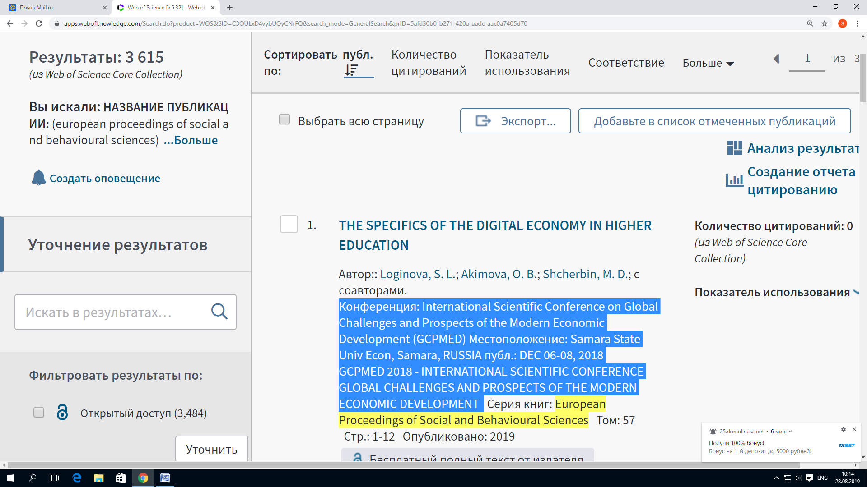

Conference sections

Section 1. Drivers of global economic development: lessons, trends and new solutions.
Section 2. Financial technologies as a key success factor of modern success, financial security.
Section 3. New management models in a dynamically changing society.
Section 4. Legal aspects of digitalization of the economy and university education.
Section 5. Digital transformation of public administration: world experience; Russian practice.
Section 6. Corporate social responsibility as a key competence of business development.
Section 7. Digital economy and new social challenges: opportunities; limitations; points of growth.
Section 8. Approaches to the study of improving the quality of life of the population.
Section 9. Corporate Finance.
Section 10. Corporate governance in the context of digital modernization.

Program Committee
Ashmarina, S. I., doctor of Economics, Professor, rector of Samara state economic University (sgeu) (Chairman)
M. A. Eskindarov, doctor of Economics, Professor, rector of the Financial University under the Government of the Russian Federation
Maslennikov V. V., doctor of Economics, Professor, Vice-rector of the Financial University under the government of the Russian Federation
A. A. Soldatov, Ph. D., associate Professor, first Vice-rector of the Russian state social University (RSSU)
A. V. Timiryazeva, Ph. D., associate Professor, rector of Kazan innovative University (IEML)

Organizing Committee
A.V. Pavlova, Doctor of Economics, Professor, Vice-Rector for Scientific Work of Samara State University of Economics (SSEU) (Chairman)
M.A. Fedotova, Doctor of Economics, Professor, Head of the Department of Corporate Finance of the Corporate Governance of the Financial University under the Government of the Russian Federation.
I.Y. Belyaeva, Doctor of Economics, Professor, Deputy. Head of the Department of Corporate Finance of the Corporate Governance of the Financial University under the Government of the Russian Federation
A.A. Bikbulatova, Ph.D., Associate Professor, Vice-Rector for Methodological Work and Inclusive Education of the RSSU
T.V. Kramin, doctor of Economics, Professor, Vice-rector for corporate governance, Director of the Institute of the problems of socio-economic development of the Kazan innovative University (IEML)
O.V. Danilova, doctor of Economics, Professor, Professor of the Department of corporate Finance, corporate governance, Financial University under the Government of the Russian Federation.
O.V. Losev, doctor of Economics, Professor, Deputy head of corporate Finance corporate governance, Financial University under the Government of the Russian Federation.
M.M. Pukhova, Candidate of Economics, Head of the Postgraduate Department of the Financial University under the Government of the Russian Federation.
V.A. Piskunov, Doctor of Economics, Professor, First Vice-Rector for Educational Work of SSEU
D.V. Chernova, Doctor of Economics, Professor, Director of the Institute of Commerce and Logistics, Head of the Department of "Commerce, Service and Tourism" of SSEU
S.N. Pichkurov, Ph.D., Associate Professor, Director of the Institute of National Economy, SSEU
N.V. Polyanskova, Candidate of Economics, Associate Professor of the Department of Regional Economics and Management, Deputy Director of the Institute of National Economy, SSEU
N.F. Tagirov, Doctor of Economics, Professor, Director of the Institute of Theoretical Economics and International Economic Relations, SSEU
A.A. Chudaeva, Candidate of Economics, Associate Professor, Deputy. Director of the Institute of Theoretical Economics and International Economic Relations, SSEU
A.P. Zhabin, doctor of Economics, Professor, head. Department of "Management" of SSEU
A.V. Streltsov, doctor of Economics, Professor, head. the Department "Economics, organization and strategy of enterprise development", SSEU
L.A. Sosunova, doctor of Economics, Professor, head. the Department of "Marketing, logistics and advertising" of SSEU
K.N. Ermolaev, doctor of Economics, Professor, head. the Department of "Institutional Economics and economic history", SSEU
M.V. Simonova, doctor of Economics, Professor, head. the Department "labor Economics and personnel management" of SSEU
E.V. Mezentseva, head. the Department "Legal support of economic activities of SSEU
Volkodavova E. V., doctor of Economics, Professor of "Management", SSEU
E.V. Pogorelova, doctor of Economics, candidate of technical Sciences, Professor, head. the Department "Enterprise information systems, e-services and intelligent information technology", SSEU
O.V. Bakanach, candidate of Economics, associate Professor, head. Department

Iveta Kmetsova, Doctor, Associate Professor of the Department of Enterprise Management, Institute of Technology and Business (Czech Budejovice, Czech Republic)
Brendan Mollow, Professor of the University College Cork (Cork, Ireland);
Anabela Mesquita, PhD, Vice-Dean ISCAP / IPP (Politechnic Institute of Porto) and former Research Director of CICE, President of SPACE network, Editor-in-Chief of International Journal of Technology and Human Interaction (IJTHI), Associate Editor of Information Resources Management Journal (IRMJ), Member and referee of the Program Committee and Scientific Committee of several National and International Conferences, Member of the Editorial Board and referee for IGI Global. Evaluator and reviewer for European Commission projects, Porto, Portugal;
Marek Vochozka, doc. Ing., MBA, Ph.D., Rector of Institute of Technology and Business in České Budějovice;
R. Vanickova, Associate Professor, Ph.D., The Institute of Technology and Business in České Budějovice, Czech Republic;
Paula Odete Fernandes, Associate Professor, Ph.D., Instituto Politécnico de Bragança; UNIAG, Department of Economics and Management (ESTiG);
Anna A. Maruashvili, Professor, Ph.D., New Higher Education Institute, Georgia;
Oxana Yu. Kogut, Associate Professor, Ph.D., Al-Farabi Kazakh National University, Almaty, Kazakhstan;
Chen Jinzhong (John), Section Chief of International Exchange, Associate Professor, International Office, Office for Hongkong Macao & Taiwan Affairs, International Education Center, Shaoxing University, China;
Engi Jin, Ph.D., Shaoxing County Technology Transfer Center, Shaoxing University, China;
V.V. Klimuk, Ph.D., Vice-rector for Scientific and International Activities of Baranavichi State University (Belarus);
G.Ya. Zhitkevich, Ph.D., Associate Professor, Baranovichi State University (Belarus);
Lu Wang, Ph.D., School of Information Management and Engineering, Zhejiang University of Finance and Economics, Hangzhou, Zhejiang;
Chong Wu, Doctor, Professor, School of Economics and Management, Harbin Institute of Technology, Harbin, China;
Jiaming Liu, Doctor, School of Economics and Management, Beijing University of Chemical Technology, Beijing, China;
Pengfei Sheng, Associate Professor, School of Economics, Henan University;
M.K. Tolymgozhinova, Ph.D., Associate Professor, Dean of the Faculty of Economics, Law and Humanities, Shakarim State University Semey (Kazakhstan);

The process of participation:

- by October 15, 2019, send a file with an article designed according to a template to the specified email address;
- after passing the initial verification and review, the authors will be sent a license agreement, which will need to be signed and sent a scanned copy to the organizers.;
- after the organizers receive the article and the license agreement, a receipt will be sent to the authors to pay for the publication.

Publication requirements:
1. Materials are accepted only in English.
2. The paper should be designed strictly in accordance with the template.
3. The text of the publication is drawn up in accordance with the given structure: Abstract Keywords Introduction, Problem statement, Research questions, Research objective, Research methods, Conclusions, Conclusion, Acknowledgements (if any), References.
4. The originality of the material in English should be at least 90%.
5. The sources in References are arranged in alphabetical order. Up to 15 sources in References, 7 of which must be foreign and indexed in the Web of Science database, no older than 5 years.
6. In the text, references to sources are made in parentheses in the format (Ivanov, 2019). The references in the text must fully correspond to the list of sources.
7. The volume of the paper should not exceed 6 pages with sources.
8. The article should have no more than 3 authors.
9. All figures and tables must be editable. If the drawing/ table is not author's, then the written permission of the author /primary source for their use is required.
10. The paper file should be named by the last name(s) of the author(s). (For example: Ivanov, Petrov, Sidorov)

Review

The submitted materials will undergo single-blind peer review process by two reviewers.

Paper Submission and Evaluation
All authors submit their materials through the conference e-mail.

Peer Review Criteria
The review criteria include: originality of the text (more than 90%), scientific novelty, contribution to the field, quality of structure and clarity, engagement with sources, language.
The review process consists of two stages. At the first (technical) stage, all the papers are proved by the technical committee (originality and template). At the second stage, the experts review the papers that passed the technical stage.

Conferecne e-mail:
E-mail: sseu.sp@gmail.com

Tel. 8(846)933-87-17; 8(846)933-88-77.

